1. Frontend — React + Vite
First-time setup
Run these commands in the VS Code terminal, one at a time.

# Step 1: Go to your frontend folder on terminal
cd D:\Skyline-Project-main\skyline-react

# Step 2: Install frontend dependencies
npm.cmd install

# Step 3: Start the frontend
npm.cmd run dev
Open the URL shown in your terminal, usually http://localhost:5173/
And run on browser
OR
Every time you want to run the frontend again
If you have already installed the dependencies, you generally only need these two commands:
cd D:\Skyline-Project-main\skyline-react
npm.cmd run dev
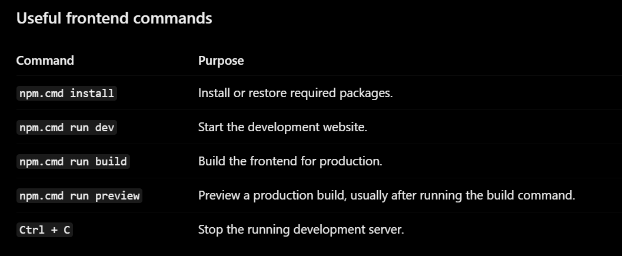
2. Backend — Django
You do not need to run this yet if you only want to view the frontend. Save these commands for when you are ready to activate the complete website.
First-time backend setup
Open a second terminal in VS Code. Keep your frontend terminal running.

